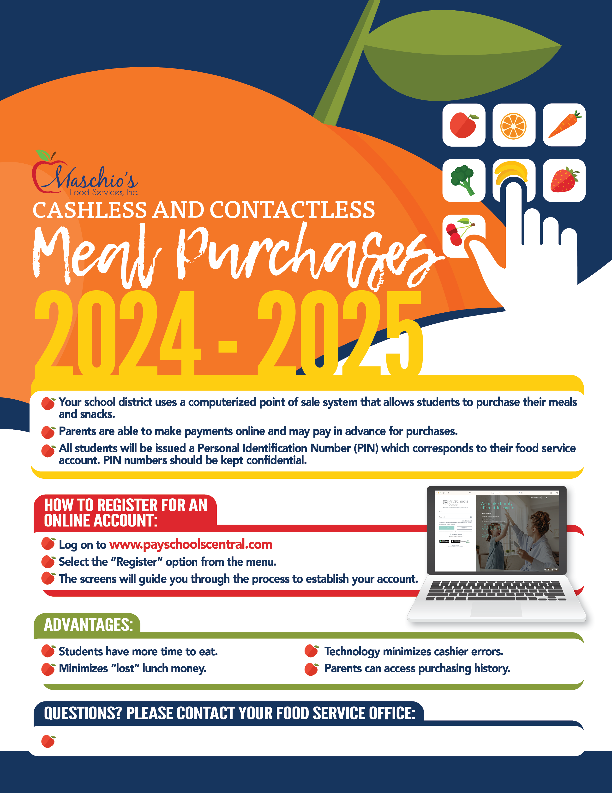

**Sarah Engst, Area Supervisor sengst@maschiofood.com**

Perth Amboy Catholic School